HTML Basics-Theory Assignment

Question 1: Define HTML. What is the purpose of HTML in web development
- HTML stands for Hypertext Markup Language.
- It is the Standard language used to create and design web pages.
Purpose of HTML in Web Development:
- It gives structure to a web page.
- It is not a programming language, but a markup language.
This means HTML is used to mark different parts of a webpage like: text, headings, Paragraphs, images, links, buttons, Tables, Forms, Videos and More.
- HTML gives the basic structure to a webpage. Just like a building needs a framework, a website needs HTML.
- Work together with other languages
- HTML gives the structure
- CSS gives the design
- JavaScript adds functionality

Question 2: Explain the basic structure of an HTML document. Identify the mandatory tags and their purposes.
<!DOCTYPE html>
<html>
<head>
<title>Page Title</title>
</head>
<body>
<h1>This is a Heading</h1>
<p>This is a paragraph. </p>
</body>
</html>
Explanation of Mandatory Tags:
Tag | Purpose (Simple Explanation)
<!DOCTYPE html> | Tells the browser that this is an HTML5 document.
<html> | The root of the webpage. It wraps all the content.
<head> | Contains information about the page, like title, styles, etc. (not shown on the page)
<title> | Sets the title of the page (shows on the browser tab).
<body> | Contains all the content you want to show on the page (text, images, links, etc.)

Question 3: What is the difference between block-level elements and inline elements in HTML? Provide examples of each.
1. Block-level Elements:
- They take up the full width of the page (from left to right).
- They start on a new line.
- Used to create larger sections of a webpage like paragraphs, headings, divs etc.
- They can have other elements inside them.

✅ Examples of block-level elements:
  - <div>This is a block</div>
  - <p>This is a paragraph</p>
  - <h1>This is a heading</h1>

2. Inline Elements:
- They only take as much space as they need.
- They don’t start on a new line.
- Used to style or format small parts of text within a line, like links, bold text, or spans.
- They stay in the same line as the text.

✅ Examples of inline elements:
- <span>This is a span</span>
- <a href="#">This is a link</a>
- <strong>Bold text</strong>

Question 4: Discuss the role of semantic HTML. Why is it important for accessibility and SEO? Provide examples of semantic elements.

- Semantic HTML means using HTML tags that describe the meaning of the content — not just how it looks.

For example:
- <p> means a paragraph
- <header> means the top section
- <nav> means navigation (menu)
- <main> Main content of the page
- <section> A part or block of content
- <article> Standalone content (like blog)
- <footer> Bottom part (contact, copyright)
- <aside> Sidebar or related info
Accessibility :
Helps screen readers read the page for visually impaired users. Semantic tags like <nav>, <main>, and <header> make it easier for them.
Seo :
Search engines like Google understand the structure better with semantic tags, which helps websites rank higher.
- Simple Example:
<article>
<header>
<h1>My Blog Post</h1>
</header>
<p>This is the content of my blog.</p>
<footer>Written by John</footer>
</article>

Question 5: What are HTML forms used for? Describe the purpose of the input, textarea, select, and button elements.
- HTML forms are used to collect user input — like names, emails, passwords, choices, feedback, etc.
For example: login forms, contact forms, surveys, Giving feedback etc.
- An HTML form is a part of a web page that allows users to enter data and send it to the server.
- There are Two Submission Methods of HTML Form.
1. GET Method
2. POST Method
Common Form Elements and Their Purpose
1. <input>
Used to take single-line input from the user like:
- Name
- Email
- Password
- Checkbox
- Radio button
And more (using type attribute)
<input type="text" placeholder="enter your name">
2. <textarea>
Used to take multi-line input like feedback or comments.
<textarea placeholder="Write your comments here"></textarea>
3. <select>
Used to create a dropdown list where users can select one (or
more) options.
<select>
<option value="gujarat">Gujarat</option>
<option value="maharashtra">Maharashtra</option>
</select>
4. <button>
Used to create a button, usually for submitting the form or
doing some action.
<button type="submit">Submit</button>

Question 6: Explain the difference between the GET and POST methods in form submission. When should each be used?

Difference Between Methods :
1. GET Method
- Sends data in the URL
- Not secure (visible to everyone)
- Used when data is not sensitive (like search)
- <form action="search.php" method="get">
- Parameter are saved in browser history
- Support only string data types
- Has a length limitation of 255 Characters
2. POST Method
- Sends data securely in the background
- Not shown in URL
- Used for passwords, login, sign-up, contact forms etc.
- <form action="login.php" method="post">
- Parameter are saved in browser history
- Support Different data type Such as, String, numeric, binary etc.
- Does not have a length limitation

Question 7: What is the purpose of the label element in a form, and how does it improve accessibility?
- The <label> tag is used to name or describe a form field like an input box, checkbox, radio button, etc.
- It tells the user what to enter in that field.
- Improves form usability and user experience
- Most importantly: improves accessibility
1. The <label> tells screen readers what each input field is for.
2. This helps blind or visually impaired users know what to enter.
Without <label>:
- A screen reader might just say “edit box” — unclear.
- The user doesn’t know what information to enter.
With <label>:
- A screen reader will say “Name: edit box”
- Now the user knows: “Oh, I have to enter my name here.”
<label for="email">Email Address:</label>
<input type="email" id="email" name="email">

Question 8: Explain the structure of an HTML table and the purpose of each of the following elements: <table>,<tr>,<td>,<th> and <thead>.
- HTML Table is used to display data in tabular form(Rows & Columns).
- There can be used many columns in a row.
- HTML Tables are used to manage the layout of the page.
Example : Header section, Navigation section, Body Content ,Footer section etc.
- An HTML Table is created using the <table>tag. inside this tag we use <tr>,<th>,<td>.
Purpose Of HTML Table elements :
Tag | Role in the Example
<table> | Starts and ends the whole table
<thead> | Groups the heading row (<tr> with <th>)
<tr> | Creates a new row (1 for headings, others for data)
<th> | Table heading cells: “Name”, “Age”
<td> | Table data cells: “John”, “25”, etc.
Question 9: What is the difference between colspan and rowspan in tables? Provide examples.
1.Colspan :
- Use colspan to merge cells left to right
- Works horizontally(left to right)
- Merging multiple columns into one
- Usually in <th> or <td>
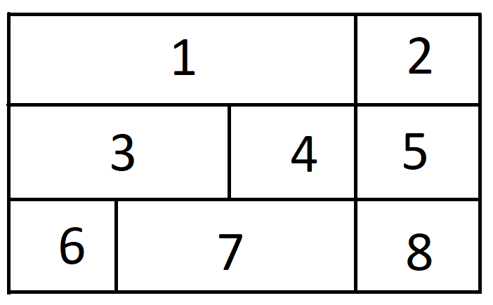

2.Rowspan :
- Use rowspan to merge cells top to bottom 1,9,7

- Works vertically (top to bottom)
- Merging multiple rows into one
- Usually in <th> or <td>
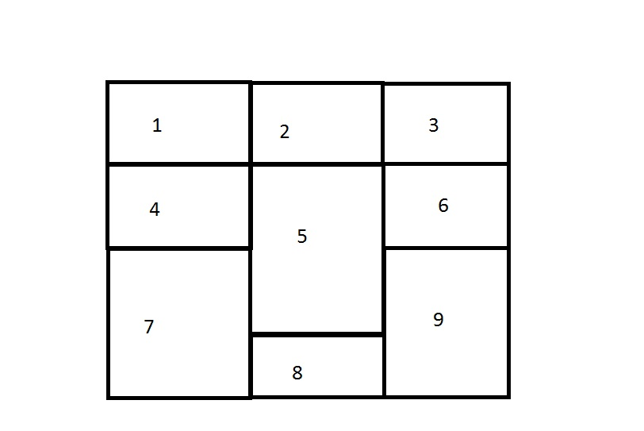
Question 10: Why should tables be used sparingly for layout purposes? What is a better alternative?

- Why tables should be used sparingly for layout:
  - They make the web page slower
  - The code becomes big and hard to understand
  - It’s not good for mobile or responsive design (doesn’t adjust well to different screen sizes)
  - It’s harder for screen readers (less accessible)
- Better alternative:
  - Use CSS layout like Flexbox or CSS Grid
  - This makes the webpage clean, fast, and responsive
In short: Use tables only for showing data, and use CSS (Flexbox/Grid) for page layout.

